CHAPTER 1
INTRODUCTION
1.1 Background Information:
The rapid growth of cloud computing, artificial intelligence, and digital technologies has created a strong demand for skilled professionals in the IT industry. However, many students and learners face difficulties in identifying the right career path and selecting appropriate courses that match their interests, skills, and industry requirements. This often leads to confusion in career planning and skill development.
Traditional learning platforms provide a large number of courses but lack personalized guidance and intelligent recommendations. As technology trends continue to evolve, learners need a system that can help them discover relevant skills, understand market demands, and receive recommendations tailored to their career goals. Integrating AI-based recommendation techniques can significantly improve the learning experience and decision-making process.
The Cloud Career Predictor was developed to address these challenges by providing personalized course recommendations, career guidance, and market trend insights. The platform analyzes user interests and experience levels to suggest suitable learning paths while helping users stay updated with industry-relevant skills. This enables learners to make informed career decisions and enhance their employability in the rapidly changing technology landscape.
1.2 Objectives and Scope:
Objectives
The primary objective of the Cloud Career Predictor is to develop an intelligent and user-friendly platform that assists learners in identifying suitable career paths and acquiring relevant skills based on their interests, experience, and professional goals. The system aims to provide personalized course recommendations and career guidance by analyzing user preferences and aligning them with current industry requirements. By integrating AI-driven recommendation techniques, the platform helps users make informed decisions about their learning journey, improve their skill sets, and enhance their career prospects in rapidly evolving technology domains. Additionally, the project seeks to bridge the gap between academic learning and industry expectations by providing insights into emerging technologies and in-demand skills.
Scope
The scope of the Cloud Career Predictor encompasses the development of a web-based platform that offers personalized learning recommendations, career guidance, and market trend analysis for students and professionals. The system focuses on technology-related domains such as cloud computing, artificial intelligence, data science, cybersecurity, and software development. It enables users to create and manage profiles, explore recommended and available courses, and gain awareness of industry trends relevant to their career interests. The platform is designed to be scalable and accessible, allowing future enhancements such as real-time job market integration, advanced predictive analytics, certification tracking, and job recommendation features. Through its intelligent recommendation capabilities, the system supports continuous learning and career development in the modern digital landscape.
1.3 Brief Overview of Methodology:
The methodology adopted for the Cloud Career Predictor involves collecting user information such as interests, experience level, and career preferences through a registration and profile management system. This data serves as the basis for understanding the user's learning requirements and career aspirations.
The system then analyzes the user inputs and matches them with a predefined course dataset containing information about various technology domains, including cloud computing, artificial intelligence, data science, cybersecurity, and software development. Based on this analysis, personalized course recommendations and suitable learning paths are generated. Users can also access an "All Courses" section to explore the complete course catalog.
Additionally, the platform evaluates course-related data to identify current market trends and in-demand skills. These insights are displayed through an interactive dashboard, enabling users to understand industry requirements and make informed career decisions. The application is implemented as a web-based system using modern technologies, ensuring accessibility, scalability, and an enhanced user experience for continuous learning and career development.

CHAPTER 2
PROBLEM STATEMENT
In today's rapidly evolving technology landscape, students and professionals often face difficulties in selecting the right career path and acquiring the skills required to meet industry demands. The abundance of online learning resources and courses makes it challenging for learners to identify the most relevant learning opportunities based on their interests, experience, and career goals. As a result, many individuals struggle with career planning, skill development, and staying updated with emerging technologies.
Traditional learning platforms provide access to numerous courses but often lack personalized recommendations and career guidance. Furthermore, learners may not have sufficient awareness of current market trends, in-demand skills, and industry requirements, leading to a mismatch between their acquired skills and employer expectations. This gap can negatively impact employability and professional growth.
The Cloud Career Predictor addresses these challenges by providing an AI-powered platform that analyzes user interests and experience levels to recommend suitable courses and career paths. The system offers personalized learning guidance, insights into market trends, and access to relevant educational resources, enabling users to make informed decisions about their learning journey and career development. Through intelligent recommendations and data-driven insights, the platform aims to bridge the gap between learners and industry requirements while promoting continuous skill enhancement and career success.

CHAPTER 3
SYSTEM DESIGN
3.1 Architectural Overview:
The Cloud Career Predictor follows a multi-layered web application architecture that integrates user interaction, business logic, data processing, and recommendation functionalities:
Layer | Components
Presentation | Login, Registration, Profile pages, Dashboard, Course catalog, Market trends page
Recommendation | Course Recommendation Engine, Interest Analysis Module, Career Guidance Module
Analytics | Market Trend Analyzer, Skill Demand Analyzer
Deployment | Vercel/Cloud Hosting Platform
Application | User Management Module, Authentication Module, Navigation Control
Data | User Profiles, Course Dataset, Market Trend Dataset
Table 3.1 - The architecture table showing Presentation, Application, Data, Analytics, Recommendation, Deployment layers with their components
The architecture is designed to provide personalized course recommendations, career guidance, and market trend analysis through a user-friendly interface. The frontend layer handles user interactions and displays personalized content, while the backend layer processes user data, recommendation logic, and application workflows. The data layer stores user profiles, course information, and market trend datasets that support the recommendation engine.
The system begins with user registration and profile creation, where information such as interests, skills, and experience levels is collected. This information is processed by the recommendation module, which matches user preferences with relevant courses from the course dataset. The market trend analysis module evaluates available data to identify in-demand skills and technologies. The generated recommendations and insights are then presented to users through an interactive dashboard, enabling effective learning and career planning.

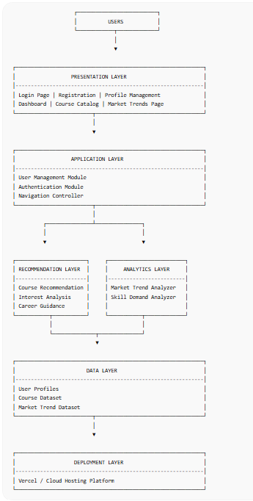
Fig 3.1- Architecture diagram
This architecture consists of six layers: Presentation, Application, Recommendation, Analytics, Data, and Deployment. Users interact with the system through the Presentation Layer, while the Application Layer manages authentication and user operations. The Recommendation Layer generates personalized course and career suggestions, and the Analytics Layer identifies market trends and skill demands. The Data Layer stores user profiles and datasets required for processing, and the entire application is hosted through the Deployment Layer on a cloud platform such as Vercel.
3.2 Flow of Operations:
The operation of the Cloud Career Predictor begins when a user registers and logs into the platform by providing basic information such as interests, skills, and experience level. The system validates the user credentials and stores the profile information for future access. Once authenticated, the user is directed to the dashboard, where personalized recommendations and learning resources are displayed.
After collecting user preferences, the recommendation engine analyzes the provided data and compares it with the available course dataset. Based on this analysis, the system generates customized course suggestions and career pathways that align with the user's interests and goals. Users can also browse the complete course catalog through the All Courses section and explore additional learning opportunities.
The system further processes course and market-related data to identify trending technologies and in-demand skills. These insights are presented through the dashboard to help users understand current industry requirements and make informed career decisions. Finally, users can track their learning progress, update their profiles, and continuously receive relevant recommendations, ensuring ongoing skill development and career growth.
3.3 System Components:
Frontend Components
- User Interface Module – Provides web pages for registration, login, dashboard access, course browsing, and profile management using React.js.
- Course Display Module – Presents recommended courses, all available courses, and course details in an interactive and user-friendly manner.
- Dashboard Module – Displays personalized recommendations, career insights, market trends, and user learning progress.
- Profile Management Module – Allows users to view and update their personal information, interests, skills, and career preferences.

Backend Components
- Authentication Module – Handles user registration, login validation, password management, and secure access control.
- Recommendation Engine – Analyzes user interests, skills, and experience levels to generate personalized course and career recommendations.
- Market Trend Analysis Module – Processes course and industry data to identify emerging technologies and in-demand skills.
- Data Management Module – Stores and manages user profiles, course information, recommendation results, and application-related data for efficient retrieval and processing.
Hardware Components
- Processor (CPU) – Executes application logic, user requests, and data processing operations required for skill analysis and recommendations.
- Memory (RAM) – Stores temporary application data and supports smooth execution of frontend and backend processes.
- Storage Device (SSD/HDD) – Stores application files, datasets, user information, and project resources required for system operation.
- Network and Client Devices – Internet connectivity and devices such as laptops, desktops, or smartphones enable users to access the platform through a web browser.
Software Components
- React.js – Used for developing the interactive frontend interface, including dashboards, forms, and recommendation pages.
- JavaScript, HTML5, and CSS3 – Provide application functionality, page structure, and responsive user interface design.
- Vite – Serves as the development and build tool for creating optimized production-ready frontend applications.
- Vercel – Cloud deployment platform used for hosting and delivering the application to end users over the internet.

3.4 Data Flow:
The data flow in the Cloud Career Predictor begins when a user registers or logs into the system through the web interface. The frontend collects user information such as interests, skills, and experience level and sends it to the backend for validation and processing. The user profile data is then stored and made available for recommendation and analysis purposes.
Once the user information is received, the backend processes the data through the recommendation engine. The system compares user preferences with the available course dataset and learning resources to identify suitable courses and career paths. Based on this analysis, personalized recommendations are generated and returned to the frontend for display on the user dashboard.
The system also analyzes course and industry-related datasets to identify current market trends and in-demand skills. These insights, along with personalized recommendations, are presented to the user through the dashboard. Any updates made by the user, such as profile modifications or learning preferences, are sent back to the backend, where the data is updated and used to generate more accurate recommendations in future interactions.
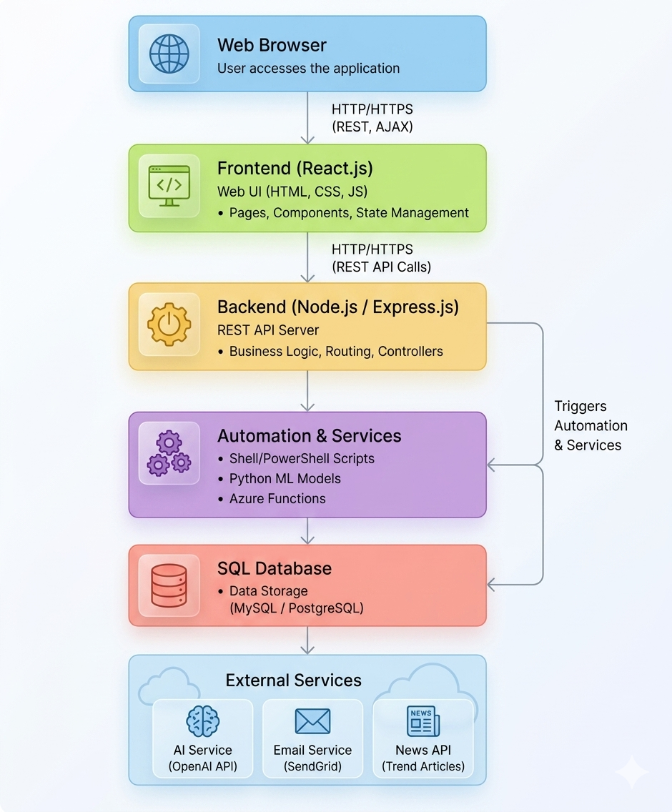
Fig 3.2 - Flow Diagram of Career Predictor
Figure 3.2 illustrates the overall architecture of the Cloud Career Predictor. Users interact with the system through a browser-based web interface developed using React.js, HTML5, CSS, and JavaScript, where they can register, log in, manage profiles, and access personalized course recommendations. The frontend communicates with the backend through API requests, while the recommendation engine analyzes user interests, skills, and experience levels to suggest relevant courses and career paths. The system also includes a market trend analysis module that evaluates course and industry datasets to identify in-demand skills and emerging technologies. All user, course, and recommendation data are managed through a centralized data layer, and the application is deployed on cloud platforms to ensure accessibility, scalability, and an enhanced learning experience.

CHAPTER 4
IMPLEMENTATION
4.1 Technology Stack:
Category | Technology | Purpose
Frontend Framework | React.js | Develops the user interface and interactive web pages.
Programming Language | JavaScript | Implements application logic and functionality.
Styling | HTML5, CSS3 | Creates the structure and visual design of the application.
Build tool | Vite | Supports fast development and optimized application builds.
Deployment Platform | Vercel | Hosts and deploys the application for online access.
Table 4.1 - The technology stack table showing Frontend, Styling, Build tool and so on
- The application uses a React.js frontend with HTML5, CSS3, and JavaScript to provide an interactive user interface for user registration, profile management, course exploration, and personalized career recommendations. The frontend is built and optimized using Vite, ensuring fast development and efficient deployment.
- The system implements an AI-based recommendation engine that analyzes user interests, skills, and experience levels to generate personalized course suggestions and career pathways. The recommendation logic processes user data and matches it with available course datasets to deliver relevant learning opportunities.
- Client-side and backend communication is performed through RESTful API requests, enabling the exchange of user information, recommendation results, and application data. The system processes requests asynchronously and delivers dynamic content to users through an interactive dashboard.
- The application includes a market trend analysis module that evaluates course and industry-related datasets to identify emerging technologies and in-demand skills. These insights help users understand current market requirements and make informed career decisions.
- The platform is deployed on Vercel, providing cloud-based hosting and accessibility. User profiles, course information, and recommendation data are managed through structured datasets, ensuring efficient data retrieval, scalability, and a seamless learning experience.
4.2 Core Modules Implementation:
- User Authentication and Profile Management Module
This module manages user registration, login, and profile maintenance. It collects user information such as interests, skills, and experience levels, validates user credentials, and stores profile data for personalized recommendations and future access.
- Course Recommendation Module
The recommendation module analyzes user preferences and compares them with the available course dataset. Based on the analysis, it generates personalized course suggestions and learning paths that align with the user's interests, skill levels, and career objectives.
- Market Trend Analysis Module
This module processes industry-related data and course information to identify emerging technologies, trending domains, and in-demand skills. The generated insights help users understand current market requirements and make informed career decisions.
- Course Management Module
The course management module maintains the course catalog and provides users with access to recommended as well as all available courses. It handles course categorization, filtering, and retrieval to ensure easy exploration of learning resources.
- Dashboard and Visualization Module
This module presents personalized recommendations, market trends, and user-related information through an interactive dashboard. It provides a centralized view of learning resources, career insights, and profile data, enhancing the overall user experience.

4.3 Key Algorithms:
- User Preference Analysis Algorithm
This algorithm collects and analyzes user information such as interests, skills, experience level, and career goals. The processed data is used to understand user requirements and create a personalized learning profile.
- Course Recommendation Algorithm
The recommendation algorithm compares user preferences with the available course dataset and identifies the most relevant courses. It ranks and suggests courses that best match the user's interests and career aspirations.
- Skill Matching Algorithm
This algorithm maps user skills and learning interests to industry-required competencies. It identifies skill gaps and recommends learning resources to help users improve their career readiness.
- Market Trend Analysis Algorithm
The system analyzes course and industry-related data to identify trending technologies, emerging domains, and in-demand skills. The results are used to guide users toward relevant career opportunities.
- Recommendation Ranking Algorithm
This algorithm prioritizes and sorts recommended courses based on relevance, user preferences, skill alignment, and career objectives, ensuring that the most suitable recommendations are presented first.
4.4 State Management:
- The Cloud Career Predictor uses state management to maintain and update user-related information throughout the application. When a user registers or logs in, details such as profile information, interests, skills, and experience levels are stored and managed within the application state. This enables seamless navigation between different modules without requiring repeated data entry.
- The frontend manages the application state using Reacts built-in state management features, allowing components such as the dashboard, profile page, and course recommendation section to access and display updated information dynamically. Any changes made by the user are immediately reflected in the interface, ensuring a responsive and interactive user experience.
- The system also maintains the state of personalized recommendations, selected courses, and market trend data. As user preferences are updated, the recommendation engine processes the new information and refreshes the displayed results accordingly. This ensures that users receive relevant and up-to-date learning suggestions.
- Additionally, browser-based storage mechanisms are used to preserve essential user data and session information during application usage. This allows users to continue their interaction with the platform smoothly while ensuring consistent access to personalized recommendations and career guidance features.
4.5 User Interface Components:
- The Cloud Career Predictor provides a user-friendly and interactive interface that enables users to access various learning and career guidance features. The application begins with a Login and Registration Interface, where users can create accounts, authenticate themselves, and securely access personalized services. This component serves as the entry point to the platform and ensures that user information is managed efficiently.
- The Dashboard Interface acts as the central hub of the application. It displays personalized course recommendations, career insights, learning progress, and market trend information in an organized manner. Through this dashboard, users can quickly access relevant information and navigate to different sections of the platform.
- The platform also includes a Course Catalog Interface and a Profile Management Interface. The course catalog allows users to browse recommended and available courses across multiple technology domains, while the profile management section enables them to update their interests, skills, and career preferences. These updates help improve the accuracy of recommendations generated by the system.
- Additionally, the Market Trends Interface presents information about emerging technologies, industry demands, and in-demand skills. By visualizing current market trends, this component helps users make informed decisions about their learning paths and career development, thereby enhancing the overall effectiveness of the platform.
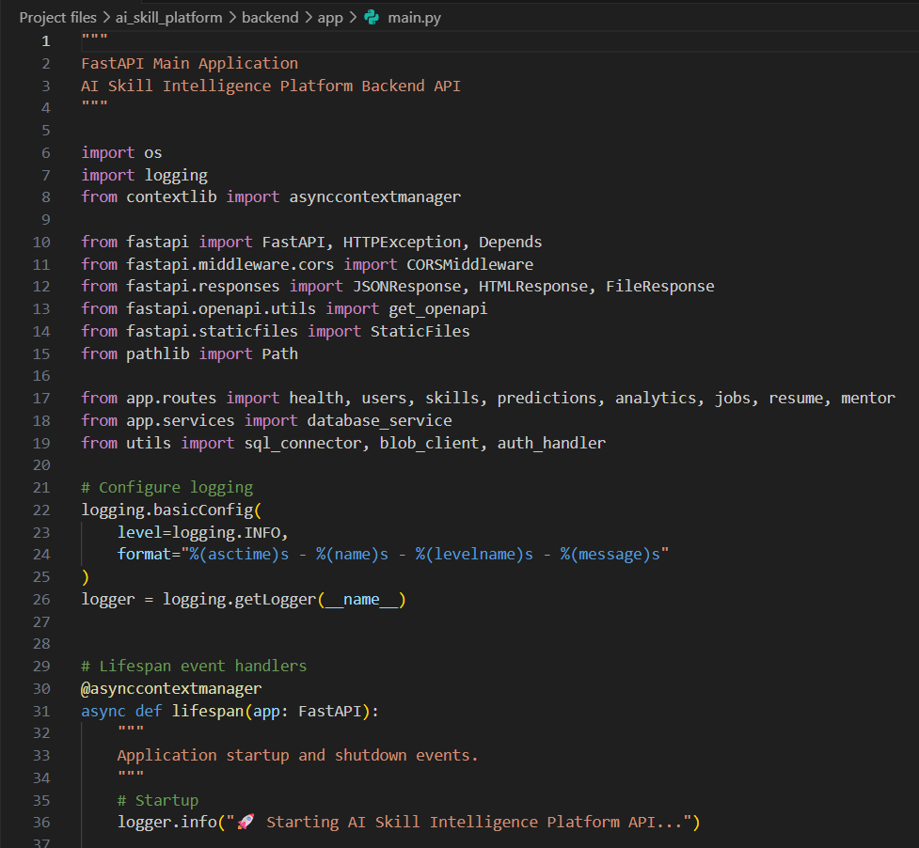
Fig 4.1 - Backend Code Snippet
Figure 4.1 illustrates the main backend application file (main.py) of the AI Skill Intelligence Platform developed using FastAPI. This file serves as the entry point of the backend system, where essential libraries, route modules, database services, and utility components are imported and configured. It initializes the FastAPI application, sets up logging mechanisms, manages application lifecycle events, and integrates various functional modules such as user management, skills analysis, predictions, analytics, jobs, resume processing, and mentoring services. The file acts as the central controller that coordinates communication between different backend components and ensures smooth execution of the platform's services.
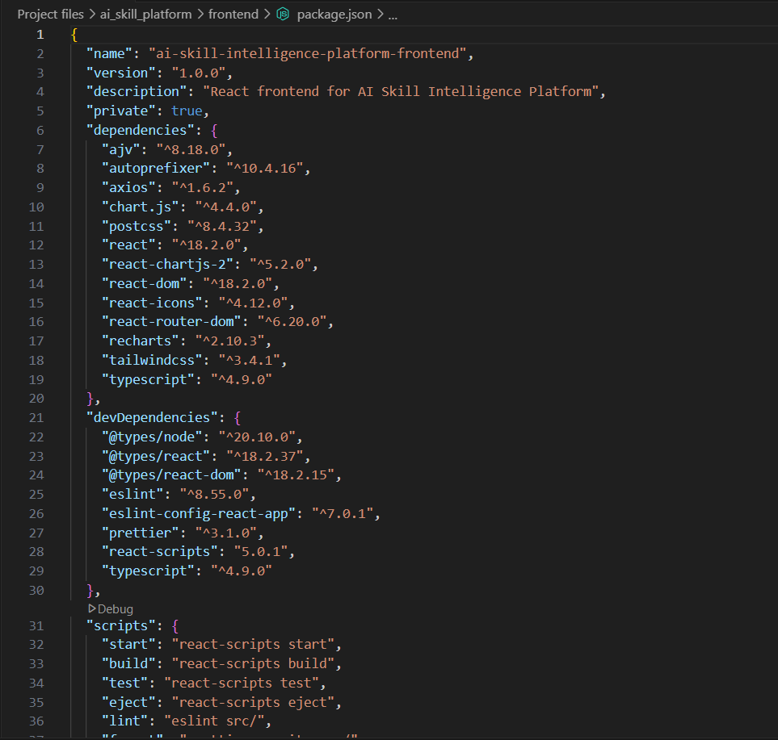
Fig 4.2 – Frontend code snippet
Figure 4.2 illustrates the package.json configuration file of the AI Skill Intelligence Platform frontend. This file defines the project's metadata, dependencies, development tools, and execution scripts required for building and running the React-based application. It includes essential libraries such as React, React Router, Axios, Chart.js, Recharts, and Tailwind CSS, which support user interface development, navigation, API communication, data visualization, and responsive design. The file also specifies development dependencies such as ESLint, Prettier, and TypeScript-related packages for code quality and maintenance. Additionally, the scripts section contains commands for starting, building, testing, and managing the application, making it a central configuration file for frontend development and deployment.
4.6 Pseudo Code
BEGIN
1. Start Application
2. Display Login / Registration Page
3. IF User is New THEN
Register User
Store User Details
ELSE
Authenticate User
ENDIF
4. Load User Dashboard
5. Collect User Information
Input Experience
Input Skills
Input Interests
Input Career Goals
6. Store User Profile Data
7. Perform Skill Analysis
Compare User Skills with Industry Skills
Identify Skill Gaps
Calculate Skill Obsolescence Risk
8. Generate Skill Gap Forecast
Analyze Future Industry Trends
Predict Required Skills
Display Skill Gap Results
9. Generate Priority Recommendations
Rank Skills Based on Demand
Recommend Relevant Courses
Suggest Learning Path
10. Calculate ROI Estimation
Analyze Learning Cost
Estimate Career Benefits
Display ROI Results
11. Generate Resilience Score
Evaluate Skill Relevance
Evaluate Learning Activity
Calculate Career Resilience Score
12. Display Trend Alerts
Monitor Emerging Technologies
Identify In-Demand Skills
Notify User of Market Changes
13. Activate AI Mentor
Accept User Queries
Provide Career Guidance
Suggest Skill Improvement Actions
14. Display All Courses
Retrieve Course Catalog
Show Recommended Courses
Allow Course Exploration
15. IF User Updates Profile THEN
Recalculate Recommendations
Refresh Dashboard
ENDIF
16. Save User Progress
17. Logout User
18. End Application
END

CHAPTER 5
RESULTS
The Cloud Career Predictor was successfully developed and implemented as a web-based platform that provides personalized course recommendations and career guidance based on user interests, skills, and experience levels. The system effectively analyzes user inputs and generates relevant learning pathways, helping users identify suitable career opportunities in various technology domains.
The application offers an intuitive and responsive user interface that enables users to register, manage profiles, explore courses, and access personalized recommendations with ease. The dashboard successfully presents recommended courses, career insights, and market trend information, improving the overall user experience and accessibility of learning resources.
The recommendation functionality demonstrated accurate matching between user preferences and available course datasets, allowing users to discover relevant courses aligned with their career goals. Additionally, the market trend analysis feature provided valuable insights into emerging technologies and in-demand skills, supporting informed decision-making and career planning.
The project achieved its objective of creating an intelligent learning and career guidance platform that bridges the gap between learners and industry requirements. The successful deployment and testing of the application confirmed its scalability, usability, and effectiveness in supporting continuous learning, skill development, and professional growth.
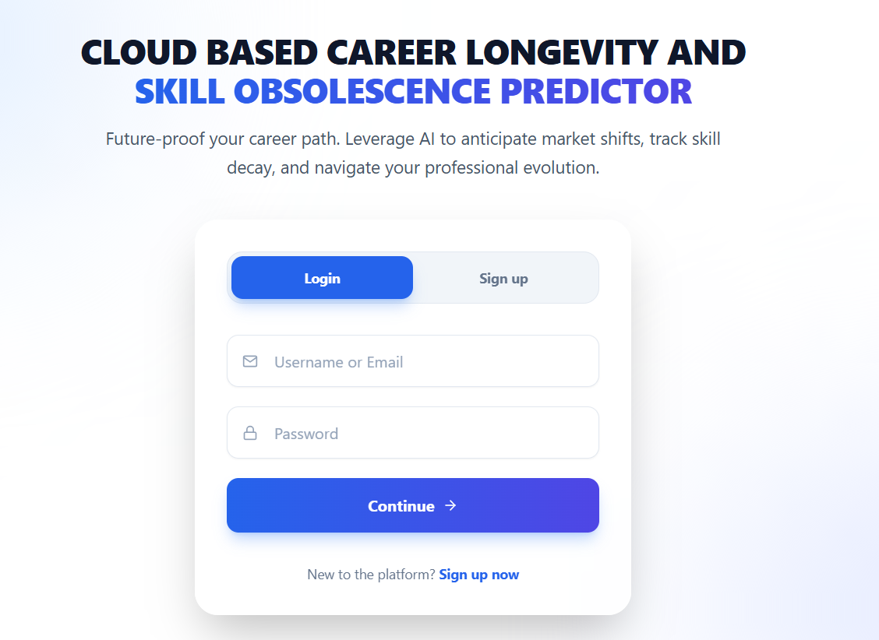
Fig 5.1 - Home Page
Figure 5.1 illustrates the Login and Registration Interface of the Cloud Based Career Longevity and Skill Obsolescence Predictor. This interface serves as the entry point to the application, allowing users to securely access the platform through login credentials or create a new account using the sign-up option. The page features a clean and user-friendly design with input fields for username/email and password, along with navigation controls for authentication. By providing secure user access and profile initialization, this module enables the system to collect user information required for generating personalized career predictions, skill assessments, and course recommendations.

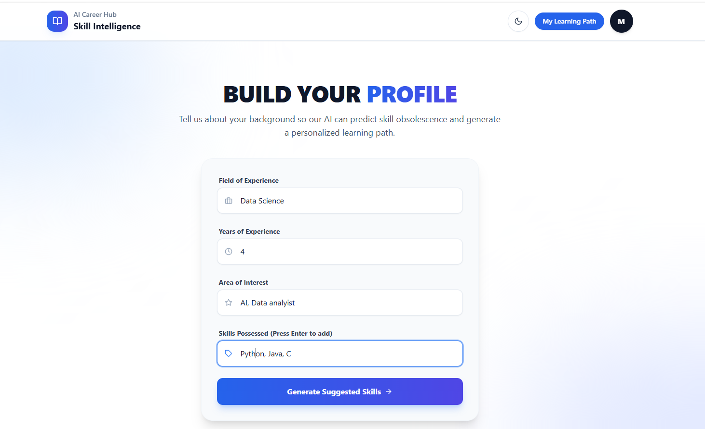
Fig 5.2 – Build profile page
Figure 5.2 illustrates the User Profile Creation and Skill Assessment Interface of the Cloud Based Career Longevity and Skill Obsolescence Predictor. This screen enables users to provide essential professional information, including their field of experience, years of experience, areas of interest, and existing technical skills. The collected information serves as input for the AI-based recommendation engine, which analyzes the user's background and predicts potential skill gaps and future skill obsolescence. Based on the submitted profile data, the system generates personalized skill recommendations and learning pathways, helping users stay aligned with evolving industry requirements and enhance their career growth opportunities.

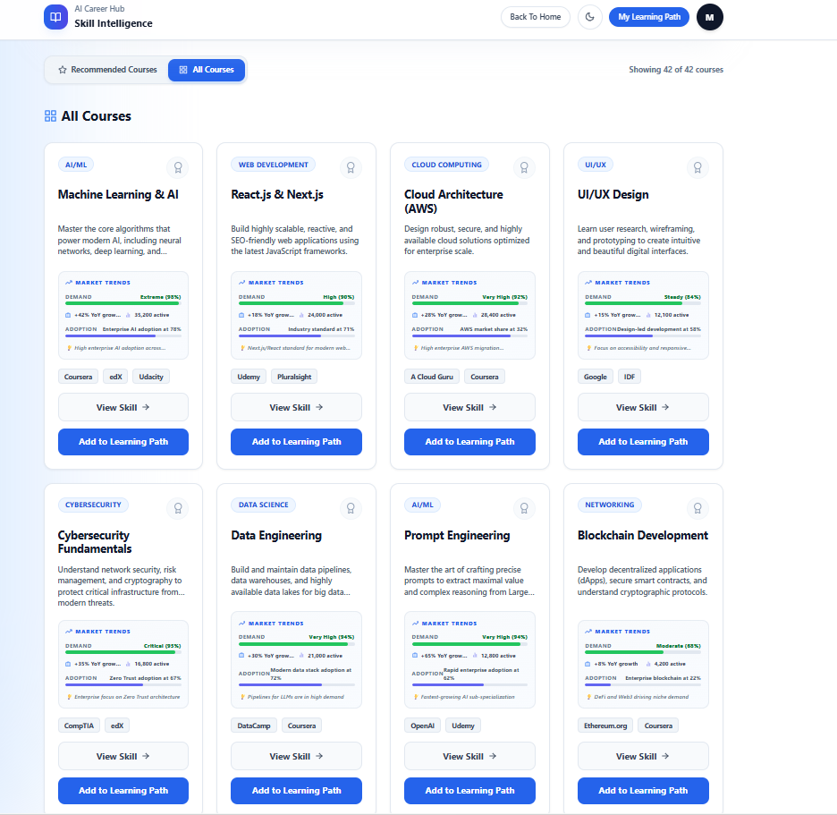
Fig 5.3- All courses available page
Figure 5.3 illustrates the All Courses Page of the Cloud Based Career Longevity and Skill Obsolescence Predictor. This page provides users with a comprehensive catalog of available courses across various technology domains such as cloud computing, artificial intelligence, data science, cybersecurity, and software development. Users can browse and explore different learning opportunities based on their interests and career goals. The interface presents course information in an organized and accessible manner, enabling users to identify relevant skill development resources. This module supports continuous learning by helping users discover courses that enhance their competencies and improve their career readiness in a rapidly evolving technological environment.

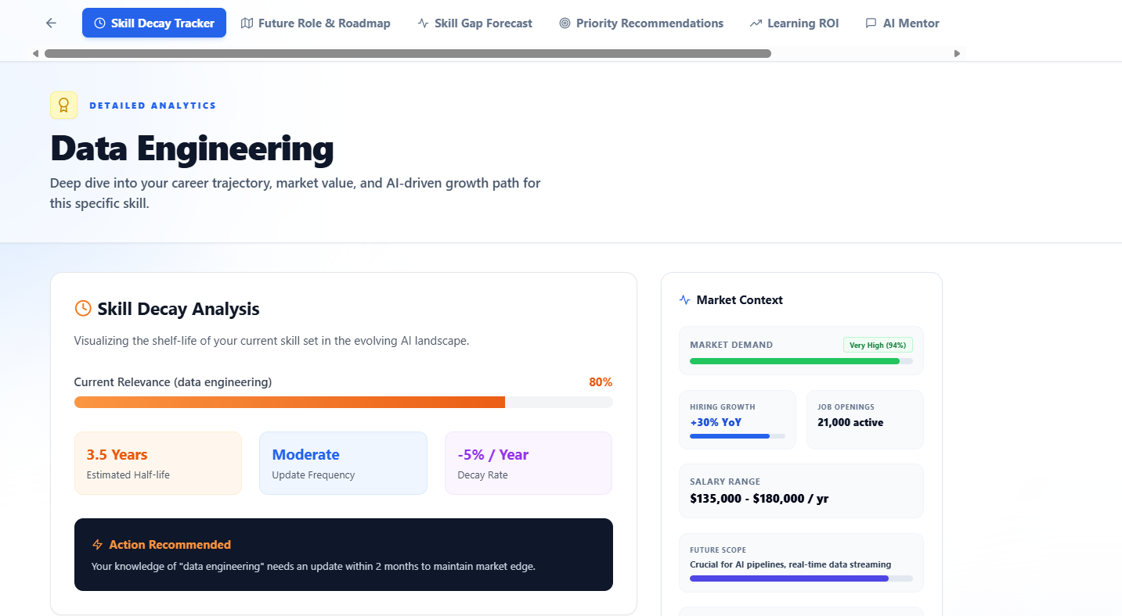
Fig 5.4- All the features available in the toolbar and Skill decay tracker
Figure 5.4 illustrates the Toolbar Features and Skill Decay Tracker module of the Cloud Based Career Longevity and Skill Obsolescence Predictor. The toolbar serves as the primary navigation component, providing quick access to various platform functionalities such as the dashboard, profile management, learning path recommendations, course catalog, market insights, and user settings. This enables users to seamlessly navigate between different sections of the application and access personalized career development resources.
The Skill Decay Tracker is a key feature that analyzes the relevance of a user's existing skills against current industry trends and technological advancements. It identifies skills that may become obsolete over time and highlights areas requiring upskilling or reskilling. By providing timely insights and recommendations, the module helps users maintain career competitiveness, adapt to evolving market demands, and plan their professional growth effectively.
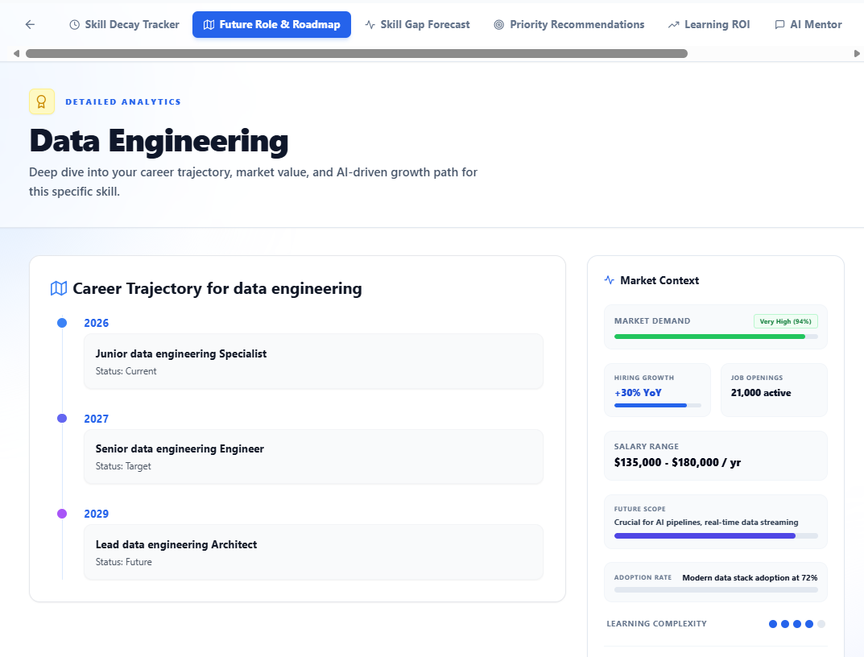
Fig 5.5- Future role and Roadmap page
Figure 5.5 illustrates the future role and development roadmap of the Cloud Based Career Longevity and Skill Obsolescence Predictor. The roadmap highlights the planned evolution of the platform from a skill assessment and recommendation system to a comprehensive career intelligence solution. Future enhancements include the integration of real-time job market analytics, advanced AI-based prediction models, personalized job recommendations, and certification tracking features. The platform is also envisioned to support mentorship programs, professional networking opportunities, and mobile accessibility to improve user engagement and career development support. These enhancements aim to provide more accurate insights, promote continuous learning, and help users adapt effectively to changing industry requirements, ensuring long-term career growth and employability.

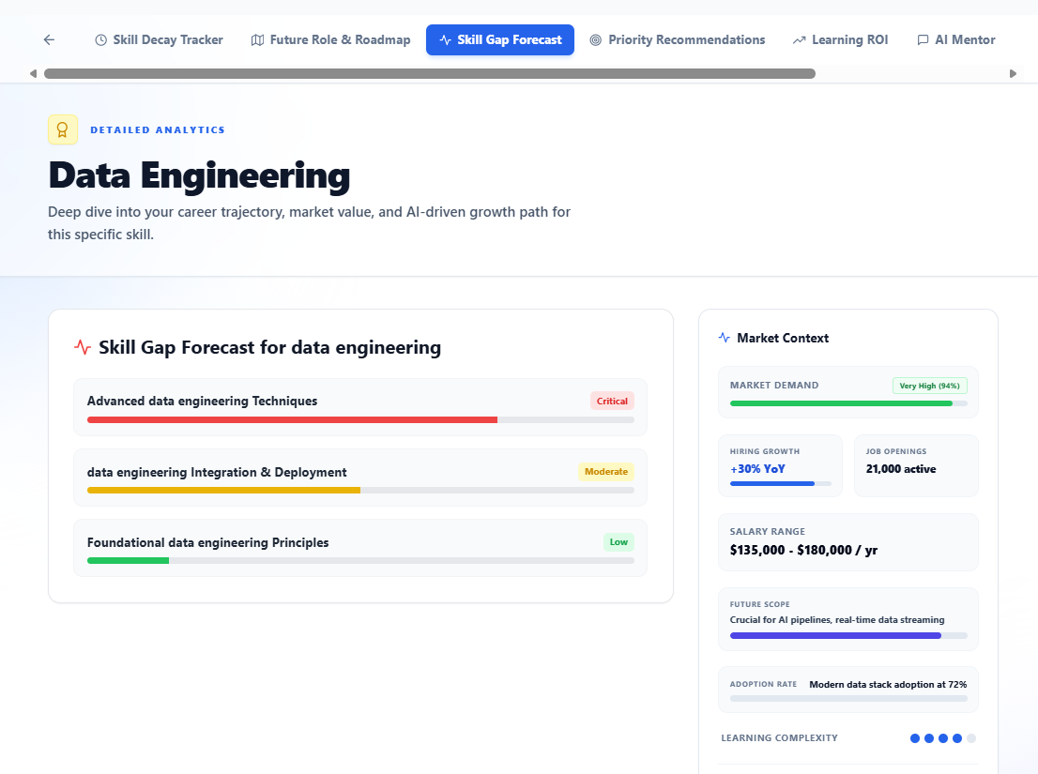
Fig 5.6- Skill gap forecast page
Figure 5.6 illustrates the Skill Gap Forecast Page of the Cloud Based Career Longevity and Skill Obsolescence Predictor. This page analyzes a user's current skills, experience, and career preferences to identify potential skill gaps that may affect future career growth. By comparing the user's skill set with current industry requirements and emerging technology trends, the system highlights areas where additional learning and upskilling are required.
The page provides predictive insights into the relevance of existing skills and forecasts future skill demands in the technology sector. Based on the analysis, personalized recommendations are generated to help users acquire new competencies and remain competitive in the job market. This feature supports proactive career planning, continuous learning, and long-term professional development by enabling users to prepare for evolving industry expectations.
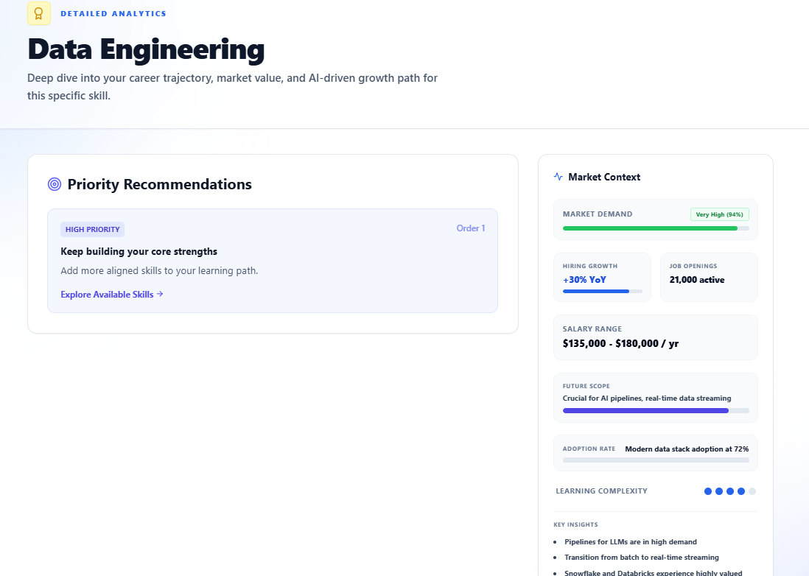
Fig 5.7- Priority Recommendation page
Figure 5.7 illustrates the Priority Recommendation Page of the Cloud Based Career Longevity and Skill Obsolescence Predictor. This page provides users with prioritized recommendations based on their current skills, career goals, skill gap analysis, and market demand trends. The system evaluates the urgency and importance of acquiring specific skills and ranks recommendations accordingly, enabling users to focus on the most beneficial learning opportunities first.
The page helps users make informed decisions by highlighting high-priority skills, courses, and career development actions that can improve employability and long-term career growth. By presenting recommendations in an organized and prioritized manner, the system supports efficient learning planning and ensures that users can effectively adapt to changing industry requirements and emerging technologies.
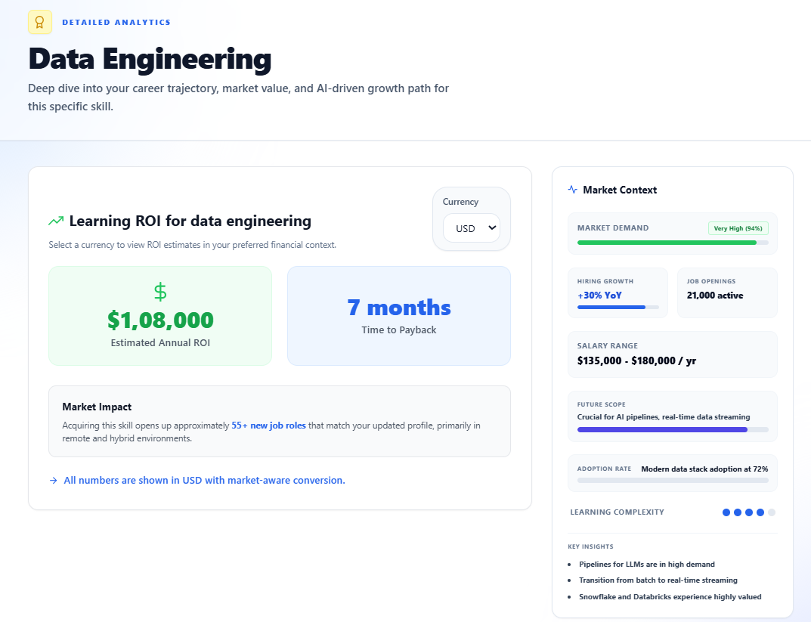
Fig 5.8- ROI estimator page
Figure 5.8 illustrates the ROI (Return on Investment) Estimator Page of the Cloud Based Career Longevity and Skill Obsolescence Predictor. This page helps users evaluate the potential benefits of investing time and resources in acquiring new skills, certifications, or training programs. The system analyzes factors such as learning costs, expected salary growth, market demand, and career advancement opportunities to estimate the potential return on investment for different learning paths.
The ROI Estimator assists users in making data-driven career decisions by comparing the value of various skill development options and highlighting those with the highest potential impact. By providing clear insights into the relationship between learning investments and career outcomes, the feature supports effective planning, resource allocation, and long-term professional growth.
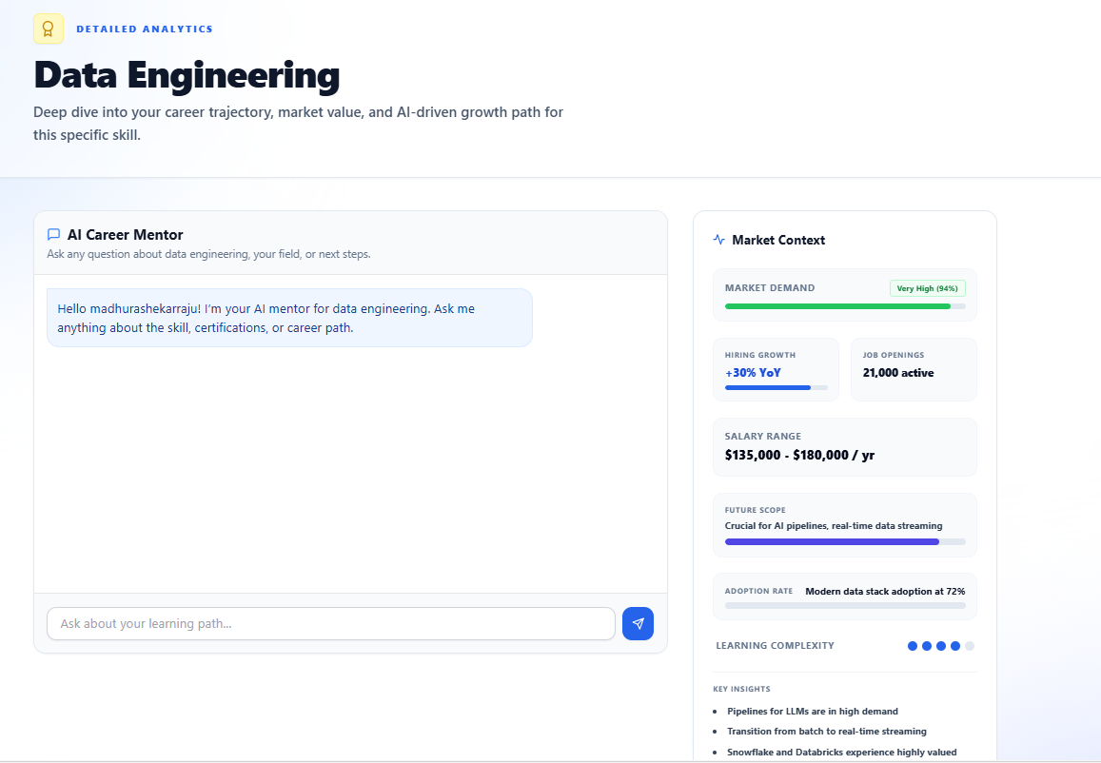
Fig 5.9- AI mentor page
Figure 5.9 illustrates the AI Mentor Page of the Cloud Based Career Longevity and Skill Obsolescence Predictor. This page provides users with an intelligent virtual mentor that offers personalized career guidance, skill development advice, and learning recommendations based on individual profiles and career goals. The AI mentor analyzes user information, skill assessments, and market trends to deliver relevant suggestions and answer career-related queries.
The AI Mentor serves as an interactive support system that helps users understand skill gaps, explore suitable learning paths, and make informed career decisions. By providing real-time guidance and personalized recommendations, this feature enhances user engagement and supports continuous professional growth in a rapidly evolving technological landscape.
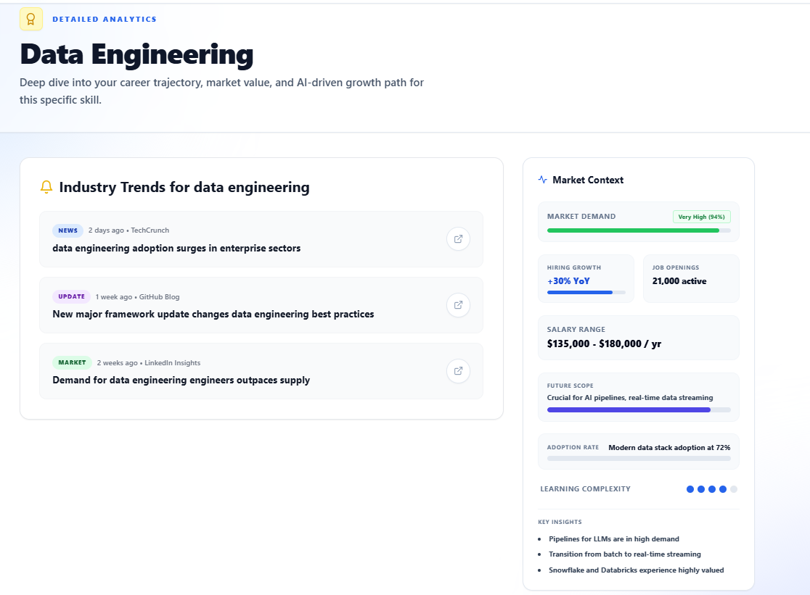
Fig 5.10- Trend alerts page
Figure 5.10 illustrates the Trend Alerts Page of the Cloud Based Career Longevity and Skill Obsolescence Predictor. This page provides users with real-time insights into emerging technologies, industry developments, and changing skill demands across various technology domains. The system continuously analyzes market trends and generates alerts to inform users about new opportunities, rapidly growing skills, and technologies that are gaining industry importance.
The Trend Alerts feature helps users stay updated with evolving market requirements and make proactive decisions regarding upskilling and career development. By delivering timely notifications and trend-based recommendations, the page enables users to maintain skill relevance, adapt to technological advancements, and enhance their long-term employability in a competitive job market.
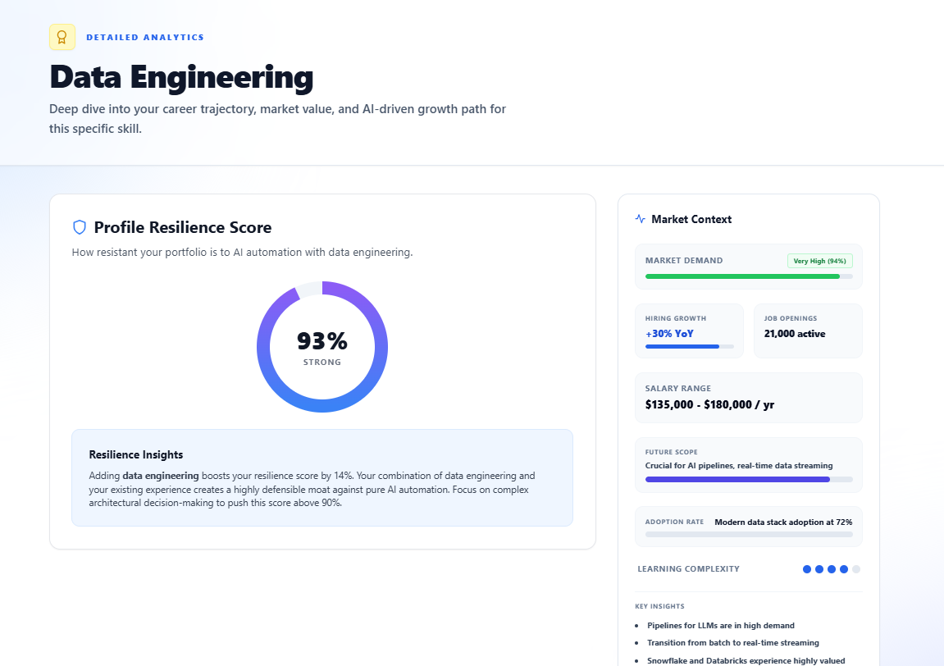
Fig 5.11- Resilience Score page
Figure 5.11 illustrates the Resilience Score Page of the Cloud Based Career Longevity and Skill Obsolescence Predictor. This page evaluates a user's ability to remain competitive and adaptable in a rapidly changing job market by analyzing factors such as current skills, experience, learning activity, skill relevance, and industry demand. Based on these parameters, the system calculates a resilience score that reflects the user's preparedness for future career challenges and technological changes.
The Resilience Score feature helps users understand their strengths and areas requiring improvement by providing personalized insights and recommendations. By monitoring career resilience over time, users can take proactive steps to enhance their skills, reduce the risk of skill obsolescence, and improve long-term career stability and growth opportunities.

CHAPTER 6
CONCLUSION AND FUTURE ENHANCEMENTS
6.1 Summary of Key Findings:
The Cloud Based Career Longevity and Skill Obsolescence Predictor successfully demonstrated the ability to analyze user skills, experience, and career interests to provide personalized learning recommendations and career guidance. The system effectively identified potential skill gaps and predicted the relevance of existing skills based on current industry trends, enabling users to make informed decisions regarding their professional development.
The project also highlighted the importance of continuous learning in a rapidly evolving technological environment. By integrating skill assessment, course recommendations, market trend analysis, and skill decay tracking within a single platform, the system provides a comprehensive solution for career planning and workforce readiness. The results indicate that the platform can assist users in maintaining skill relevance, improving employability, and adapting to changing industry demands.
6.2 Implications of Results:
The results of the Cloud Based Career Longevity and Skill Obsolescence Predictor demonstrate that AI-driven career guidance systems can play a significant role in helping individuals adapt to rapidly changing industry requirements. By identifying skill gaps and predicting potential skill obsolescence, the platform enables users to proactively update their competencies and remain competitive in the job market. This contributes to improved career planning, informed decision-making, and enhanced professional growth.
The project also highlights the growing importance of continuous learning and personalized education in the digital era. Through the integration of skill assessment, market trend analysis, and course recommendation features, the platform provides a practical solution for lifelong learning and workforce development. The successful implementation of the system suggests that similar intelligent career-support platforms can be adopted by educational institutions, training organizations, and professionals to promote skill relevance, employability, and long-term career sustainability.

6.3 Recommendations for Future Work:
- The system can be enhanced by integrating real-time job market data from employment portals and industry sources. This would enable users to receive updated information about job opportunities, hiring trends, and skill requirements, making career recommendations more accurate and aligned with current industry demands.
- Future versions of the platform can incorporate advanced machine learning and predictive analytics techniques to improve the accuracy of skill obsolescence prediction and career forecasting. More sophisticated models can provide deeper insights into emerging technologies and future workforce requirements.
- A dedicated certification and learning progress tracking feature can be introduced to monitor users’ completed courses, certifications, and skill development milestones. This would help users evaluate their growth over time and identify areas that require further improvement.
- The platform can be expanded to include a job recommendation module that suggests suitable employment opportunities based on users’ skills, experience, interests, and career goals. This would create a stronger connection between learning activities and career advancement.
- Future enhancements may include mentorship programs and professional networking features that allow users to connect with industry experts, career counsellors, and experienced professionals. Such interactions can provide valuable guidance, practical insights, and career development opportunities.
- Developing dedicated mobile applications for Android and iOS platforms would improve accessibility and user engagement. Mobile support would allow users to access career insights, skill recommendations, and learning resources anytime and anywhere, promoting continuous learning and professional development.

